Lab 3

- Goofy has thought of a new way to sort an array arr of n distinct integers:
  - Step 1: Check if arr is sorted. If so, return.

  - Step 2: Randomly arrange the elements of arr (Hint: this can be done in O(n))

  - Step 3: Repeat Steps 1 and 2 until there is a return.

Answer the following:

  - Will Goofy’s sorting procedure work at all? Explain
Solution:
Goofy procedure did,nt work as without just one case which is if the array is already sorted , may be the array will never be sorted and taked unlimited time to sort out.
  - What is a best case for GoofySort?
Solution:
The best case for GoofySort is if the array is already sorted and it return.
  - What is the running time in the best case?
Solution:
The running time for the best case is Θ(n) as it tooks n times to sort the array.
  - What is the worst-case running time?
Solution:
The worst case will be if the array is in random order so in that case the running time might be Infinity and array will never be sorted.
  - Is the algorithm inversion-bound?
Solution:
This is not the inversion bound algorithm as in this case the number of comparisons are lesser than the number of inversion so we can say that this is not inversion bound.

- Interview Question. An array A holds n integers, and all integers in A belong to the set {0, 1, 2}. Describe an O(n) sorting algorithm for putting A in sorted order. Your algorithm may not make use of auxiliary storage such as arrays or hashtables (more precisely, the only additional space used, beyond the given array, is O(1)). Give an argument to explain why your algorithm runs in O(n) time.
Solution:
As I have attached my Lab with this document which explains about that solution.
The running time of my algorithm is Θ(n) as upon computing the primitive operations according to first rule , the loop is going to be executed n times so its running time will be Θ(n) which we can also say that O(n) times.

- BubbleSort

    - Improve the BubbleSort implementation so that when the input array becomes sorted after some runs of outer for loop, the algorithm will stop. Call your new Java file BubbleSort1.java.
Solution:
Attached the java File

    - Recall that in BubbleSort, at the end of the first pass through the outer loop, the largest element of the array is in its final sorted position. After the next pass, the next largest element is in its final sorted position. After the ith pass

(i=0,1,2,…), the largest, second largest,…, i+1st largest elements are in their final sorted position. Use this observation to cut the running time of BubbleSort in half. Implement your solution in code, and prove that you have improved the running time in this way. Call your new Java file, which contains the improvements from this problem and the previous problem, BubbleSort2.java.
Solution:
Attached the java file

    - In this lab folder, I have given you an environment for testing sorting routines. Insert into this environment the original BubbleSort file along with your new BubbleSort1 and BubbleSort2 classes, and run the SortTester class. What are the results? Are the results what you expected? Explain why the running times turned out the way they did.

Solutions:

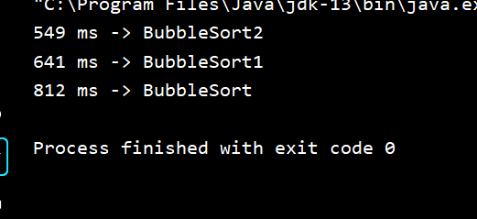

As from the running time it is clear that the running time of Bubble sort 2 is better than the running time of Bubble sort 1 and Bubble sort is worst than all of them. As we know that Asymptotically the running times of all are Θ(n²) but practically bubble sort 2 is better. As running times depends upon the number of primitive operations performed so in Bubble sort2 we are limiting the inner and outer loop both while in Bubble sort 1 we are limiting the outer loop and in bubble sort we are not limiting any loop that’s why the running times of all have a lot of difference.

- Interview Question. You are given a length-n array A consisting of 0s and 1s, arranged in sorted order. Give an o(n) algorithm that counts the total number of 0s and 1s in the array. Your algorithm may not make use of auxiliary storage such as arrays or hashtables (more precisely, the only additional space used, beyond the given array, is O(1)). You must give an argument to show that your algorithm runs in o(n) time.
Solution:
Attached the file for java code.
As we are doing the binary search to solve this problem , so the running time for this algorithm is log(n).

